**Conveyor Pizza Oven**

**Installation & Operation Manual**

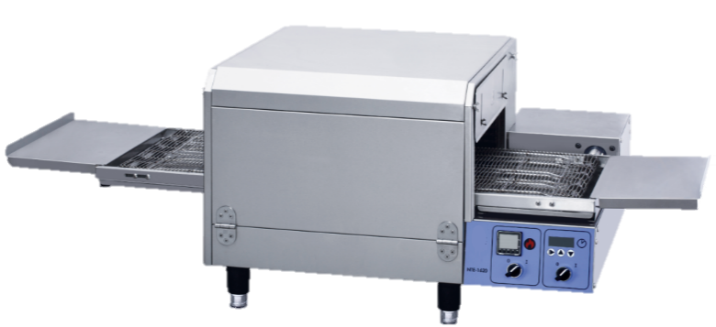

**MODEL:**

CPZ16

**Manufacturer** recommends using a certified technicians. Please read all sections of this manual and retain for future reference.

**Key symbols**

**WARNING!**

This symbol highlights potential dangerous situations which might lead to serious injury or death

**DANGER!**

This symbol highlights dangerous situations which could lead to serious injury or death

**CAUTION!**

This symbol highlights potential dangerous situations which could lead to light injury

 **DANGER!**

Be careful. Life is at risk. Failure to comply may result in electrical shock

**IMPORTANT SAFETY INSTRUCTIONS**

 **RECOGNIZE THIS SYMBOL AS A SAFETY MESSAGE**

 **WARNING**

**When passing on/selling the device to a third party, the manuals must be handed over along with the device. All users must operate the device complying with the user’s manual and related safety guidelines.**

**This manual should be placed somewhere nearby this device and easy to access.**

Recommend to sign a service and maintenance contract with manufacturer authorized service provider.

**Warning！**

Do not store anything or use petrol or inflammable & volatile substance anywhere near it.

**Warning！**

Inappropriate installation, adjustment, tamper or service will result in property loss, injury or even death. Please read carefully before operation and service.

**Important！**

Electric circuit diagram and manual book are within the packing bag.

**Important！**

It is the responsibility of the customer to inform the shipping company that any visible or hidden damage to the equipment found during unpacking and keep all shipping documents for future claim with shipping company.

**Notice！**

Use any spare parts which are not provided by manufacture, we will cancel your warrant.

**Notice！**

Manufacturer will reserve all rights to alter product specification.

**Notice！**

Device must be installed, debugged and serviced by factory authorized staff, otherwise will result in invalid warrant.

**Notice！**

It is designed for commercial kitchen, it should be used by trained staff.

** Caution！**

This appliance is NOT intended for use by persons (including children) with reduced physical, sensory or mental capabilities, or lack of experience and knowledge, unless they have been given supervision or instruction concerning use of the appliance by a person responsible for their safety.

** Warning！**

If there is any damage in the power cord, please ask a qualified service technician to change

** Warning！**

Disconnect the device from power supply before repair, maintenance or cleaning.

** Warning！**

The appliance must not be powered by an external switching device, such as a timer, or connected to a device that is regularly switched on or off.

** Warning！**

Do not use water jet to clean the equipment.

** Warning！**

Do not attempt to move the device or transfer the hot liquid to another when the device is at cooking temperature or filled with hot liquid. If the skin comes into contact with a hot surface or liquid, serious body injury may result.

** Warning！**

Do not sit or stand on this device. The front panel of electric appliances, door, and the top are not allowed to trample. Slip, fall, or contact with hot liquids can cause serious injury.

** Warning！**

NEVER use the appliance as a step for cleaning or accessing the ventilation hood. Serious injury could result from slips, trips or contact with hot liquids.

**Warning!**

The appliance is intended for commercial use, such as in restaurants, cafeterias, hospital kitchens and commercial enterprises such as bakeries and meat shops, but not for continuous mass production of food.

** Warning！**

This equipment is intended for indoor use only.

** Warning！**

Do not operate appliances unless all panels and access covers are properly connected.

** Warning！**

It is recommended that the performance and operation of the equipment be inspected annually by a qualified maintenance technician.

Please retain for future reference

**Table of Contents**

**Key symbols** 2

1. BRIEF INTRODUCTION 6

1.1 Main features 6

1.2 Features 6

1.3 Maintenance 6

1.4 Assist 6

1.5 Security 6

2. INSTALLATION 7

2.1 Introduction 7

2.2 Unpacking 7

2.3 Installation space requirements 7

2.4 Ensure ventilation 8

2.5 power supply requirements 8

2.6 Power supply installation instructions 8

2.7 Overall dimension 10

3. OPERATION INSTRUCTION 11

3.1 Position and function of the controller 11

3.2 Normal startup operation steps 12

3.3 Normal shutdown operation steps 12

4. MAINTENANCE 13

4.1 Everyday 14

4.2 Every month 14

4.3 Every season 15

5. ELECTRICAL SCHEMATICS 15

5.1 Wiring Diagram, CPZ16, 220V and 240V 16

5.2 Wiring Diagram, CPZ16, 380V and 400V 17

6. TROUBLESHOOTING 18

# 1. BRIEF INTRODUCTION

## 1.1 Main features

This device can be used to bake or cook a wide variety of foods, such as pizza, pizza-like foods, cookies, sandwiches, etc.

## 1.2 Features

• easy to clean

• stainless steel construction

• overlay design

• 1/2 layer

• multiple protection

• Circulation thermal cycle

## 1.3 Maintenance

Like other food equipment, this device need to be maintained and cleaned as part of daily maintenance.

## 1.4 Assist

If you need any assistance please contact our agent or the technical support department of manufacturer.

## 1.5 Security

Safety is an important feature of our products. Proper installation, operation and maintenance are the only way to ensure safety.

# INSTALLATION

**Warning!**

Do not install the equipment in places with inflammable, explosive or corrosive gas, dust, etc.

**Warning!**

It is highly recommended to install the leakage protector, which shall be confirmed by the professional and technical personnel of the installation company designated by our company.

**Warning!**

Equipment lines must be reliably grounded, and equipotential terminals of equipment are recommended to be connected.

**Warning!**

Relevant protective measures must be taken for equipment operation.

**Warning!**

Do not install, move or repair the equipment by yourself, otherwise our company will not be responsible for warranty and safety.

## 2.1 Introduction

This chapter provides installation method for pizza oven.

**Be careful!**

The installation needs to be completed by professionals.

**DANGER!**

Do not use a pistol drill or screw to drill holes in the machine shell, which may damage the structure or cause electric shock.

## 2.2 Unpacking

Device goes through inspection and test before it is packed into thick carton packing box with plywood pallet. It can stand the normal transportation bumping.

**Be careful!**

Any damage found prior to unpacking should be reported to the shipper.

## 2.3 Installation space requirements

There should be at least 75mm space on the left and right sides of the oven, at least 25mm space on the back of the oven, and at least 915mm space on the front of the oven. During maintenance, there should be 457mm space on both sides of the oven. If there are other cooking equipment on both sides of the oven, there should be 609mm space.

## 2.4 Ensure ventilation

The oven should be equipped with exhaust fan and other ventilation equipment, to ensure that the odor and soot produced by cooking food can be timely discharged, and to avoid affecting the operation, we recommend you to find a professional company to install exhaust equipment.

## 2.5 power supply requirements

Refer to the following parameters:

Model Voltage (V) Phase Power (kW) Current (A)

CPZ16 220-240/380-415 Single /Three 6.7 30/10

**Attention!**

The electrical parameters of different types of ovens are different, for specific parameters, please refer to the rating plate of the equipment.

**Danger!**

In order to avoid electric shock, the oven needs to be fully grounded, please refer to the relevant local standards and documents.



## 2.6 Power supply installation instructions

1. Power cord specification, circuit breaker:

CPZ16 3 cores / 4 mm2 above. Circuit breaker 40A

CPZ16 5 cores / 1.5mm2 above. Circuit breaker 20A

2. Leakage protector

It is highly recommended to install leakage protector, and the decoupling current of leakage protector shall not be less than 30mA.

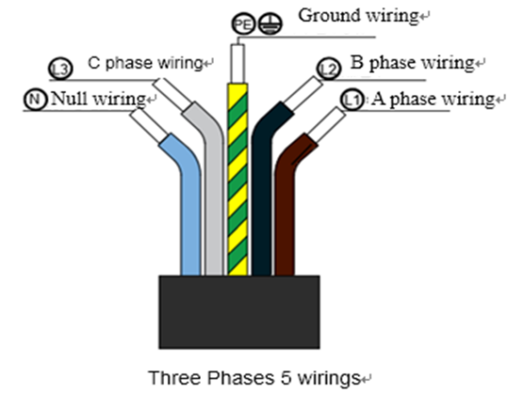

3. Power cable connection

The power supply is connected as shown in the picture.

Please connect the device with the automatic circuit breaker and then the power supply.

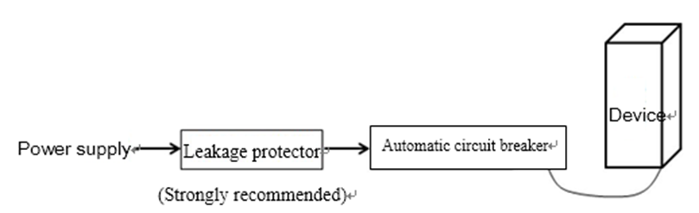

Consult a qualified electrician if doubt exists on electric connection.

**Warning!**

If the power supply is outside, please pay attention to the water proof and dust proof measures

**Warning!**

When connecting the power cord, make sure the connection of each core wire is firm and the power cord is locked tightly. The connecting terminals will not be loosened even with external force, otherwise it may cause danger. The power cord shall be oil resistant sheathed cable, not lighter than the sheathed cord of ordinary neoprene or other equivalent synthetic rubber (YZW). If the power cord is damaged, the power cord must be replaced with the power cord of the same specification

**Warning!**

To avoid the risk due to worn power cord, bushing must be installed at the outlet of the power cord and at the hole through which the power cord passes

**Danger!**

This product must be grounded, or it may cause electric shock or even death.

The electrical wiring of the equipment must be connected to a separate power supply by a qualified electrical technician.

Each device must be fitted with a double-way insulated switch with an appropriate rated capacity and contact spacing more than 3mm

**Warning!** 

When connecting the ground wire, ensure that the power cord is connected to the ground wire terminal when acted upon by external forces

**Caution!**

When the length of the power cord is insufficient, please REPLACE with a new power cord with sufficient length. DO NOT CONNECT TWO POWER CORDS TOGETHER FOR EXTENTSION

**Equipotential**

**The back of the equipment has an equipotential ground point for separate grounding (GND)**

## 2.7 Overall dimension

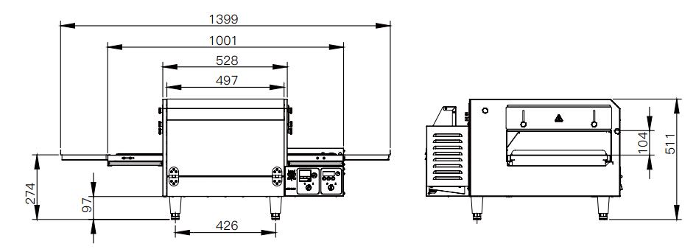

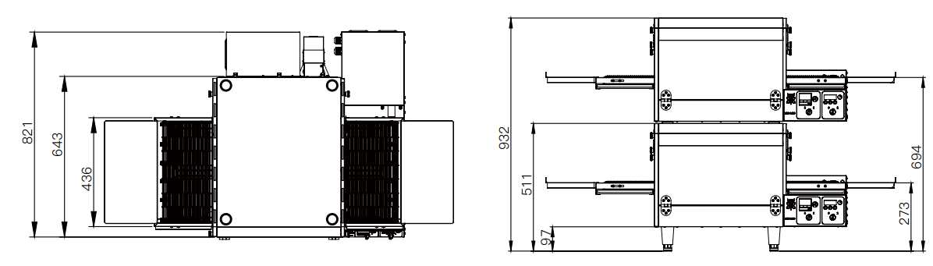

CPZ16

# OPERATION INSTRUCTION

## 3.1 Position and function of the controller

CPZ16 display board

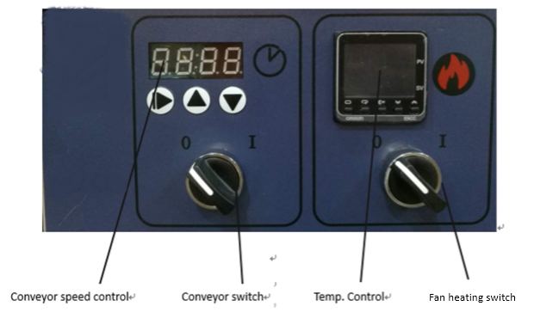

## 3.2 Normal startup operation steps

|  |  |
| --- | --- |
| Step | operation |
| 1 | Check whether the air switch or fuse switch is in the “on” position. |
| 2 | Turn on the fan heating switch to the "I" (on) position. |
| 3 | Turn on the conveyor switch to the "I" (on) position. |
| 4 | If necessary, change the baking time by pressing the up arrow key or the down arrow key of the conveyor speed controller. |
| 5 | If necessary, adjust the set temperature by pressing the up arrow key or the down arrow key on the temperature controller. Note that the set temperature is displayed in the lower window of the thermostat, and the actual temperature of the oven is displayed in the upper window of the thermostat. |
| 6 | Check that the "out" indicator light should be on to indicate that the heating element has been turned on.  When the temperature of the oven is higher than 90 ℃, the indicator "sub1" will also be on. |
| 7 | Wait for the oven temperature to reach the set temperature. The higher the set temperature, the longer the waiting time. It takes about 15 minutes for the oven to reach the set temperature of 210 ℃. |
| 8 | When the oven reaches the set temperature, allow it to preheat for another 10 minutes. |
| 9 | If necessary, in the power on state, change the direction of the conveyor belt by long pressing  of the conveyor speed control. |

## 3.3 Normal shutdown operation steps

|  |  |
| --- | --- |
| Step | operation |
| 1 | Turn off the fan heating switch and conveyor switch to the "0" position, and open the window of the oven, so that the temperature of the oven can be cooled down a little faster.  Note: the blower will remain in operation until the oven temperature has cooled to 90 ℃. |
| 2 | When the oven is completely cooled and the blower is stopped, turn off the air switch and fuse fusing switch of the power supply. |

**Caution!**

In case of power failure, turn off all switches to "0" position, open the window and take out the food inside. When the power supply is normal, repeat the normal startup steps. If the oven has been shut down for less than 5 minutes, wait at least 5 minutes before turning it on.

**Please do not operate the oven in case of power failure.**

# MAINTENANCE

**Warning!**

Before any cleaning, maintenance and repair of this device, please perform the following steps:

1. Turn off the device and wait for it to cool down. Do not clean, maintain or repair the oven before it cools down.

2. Turn off the circuit breaker on the power supply of the oven, or disconnect the power supply of the oven.

After cleaning, maintenance and repair of this device:

1. If the oven has been moved during cleaning and maintenance, please move the oven back to its original position.

2. If the power cord is disconnected due to cleaning and maintenance, please reconnect it.

3. Turn on the circuit breaker on the power supply for the oven.

4. Start the machine according to the normal operation steps.

**Warning!**

The operating parts or electrical parts in the oven may cause harm to people. Please turn off the air switch on the power supply and disconnect the power supply before cleaning, reinstalling or repairing the oven. Never attempt to disassemble or clean the oven before the blower switch or other circuit switch of the oven is turned off.

**Caution!**

When cleaning the oven, do not use water pipe or pressure steam to wash, do not use excessive water, so as not to infiltrate and damage the insulation of the oven, and do not use corrosive oven cleaning agent, otherwise the surface of the device will be damaged.

**Attention!**

Any repair or replacement of parts must be carried out by a maintenance operator authorized by manufacturer. We also strongly recommend that the ovens should be maintained every three months and every six months by an authorized oven-repair service provider.

## 4.1 Everyday

|  |  |
| --- | --- |
| Step | operation |
| 1 | Please check that the oven is cooled and the power is completely turned off according to the warning at the beginning of this chapter |
| 2 | Clean the outside of the oven with a soft cloth and medium detergent |
| 3 | Use a hard nylon brush to clean the cooling fan net and the cooling air outlet, net and air outlet |
| 4 | Check that all cooling fans are operating properly (there is flowing wind in and out of the electrical box) |
| 5 | Use a hard nylon brush to clean the conveyor belt. Please do this cleaning at the end of the conveyor belt. It will be easier. |
| 6 | Remove crumb pan and clean. |

**Be careful!**

If the cooling fan does not work properly, replace it immediately. If the oven runs without sufficient cooling, the parts inside the oven will be damaged.

## 4.2 Every month

|  |  |
| --- | --- |
| Step | Operation guidelines |
| 1 | Make sure oven is totally power off and unplugged. Don't clean the oven until it's cool down. |
| 2 | Remove the following components from the oven: crumb pan, a part of conveyor outlet frame cover, side plate, conveyor assembly. |
| 3 | When taking out each air guide box and shutter, write down the installation position number with a marking pen, so as to confirm that the installation will not be wrong, for example:  （Top） T1 T2 T3 T4 （Bottom） B1 B2 B3 B4 |
| 4 | Also write a number on the three components of  each air guide box that you disassembled, which  can help you assemble the air guide box correctly.  Be careful  Improper assembly will change the baking  performance of the oven. |
| 5 | Clean the components of the air guide box and clean the inside of the oven with a vacuum cleaner and wet cloth. |
| 6 | Assemble the air guide box, and then install the air guide box back into the oven according to the position number written on it. |
| 7 | Reinstall the side plate on the oven |
| 8 | Reinstall conveyor belt |
| 9 | Check the tightness of the conveyor belt, which should be able to pull up 2-3 "(50-70mm). If necessary, adjust the belt tightness by turning the belt tightness adjusting screw at one end (right side) of the belt retaining shaft. |
| 10 | Re-install the crumb pans. |

## 4.3 Every season

|  |  |
| --- | --- |
| Step | operation |
| 1 | Please check whether the oven has cooled down and the power supply has been completely turned off according to the warning at the beginning of this chapter. |
| 2 | Clean the blower motor and its surrounding parts |
| 3 | Check and tighten the terminals on the controller. |
| 4 | Check the blower belt. Check that the center of the blower Belt should be 1 "(25 mm) tight and that the belt is not cracked or excessively worn. Too tight belts can cause premature bearing damage and vibration. If necessary, loosen the four fixing bolts of the fan motor, move the motor position until the proper tightness is reached, and then tighten the fixing bolts. |

# ELECTRICAL SCHEMATICS

## 5.1 Wiring Diagram, CPZ16, 220V and 240V

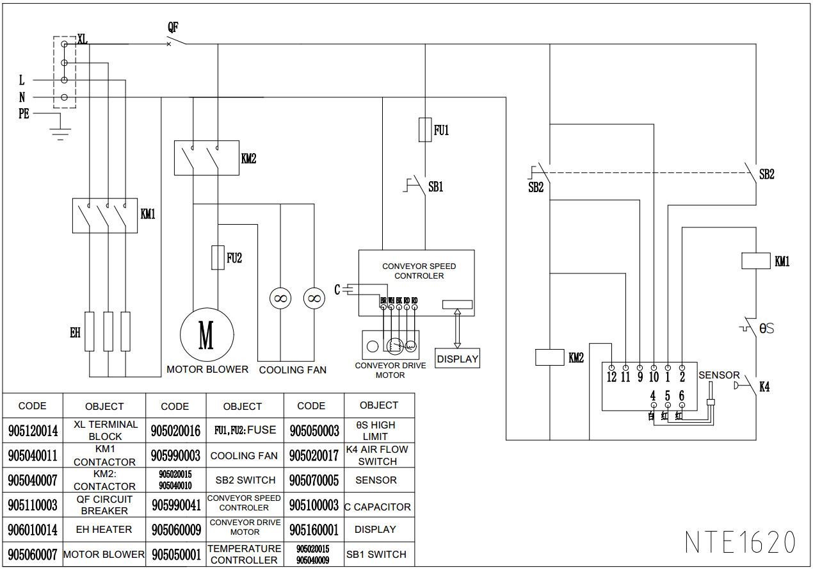

CPZ16

## 5.2 Wiring Diagram, CPZ16, 380V and 400V

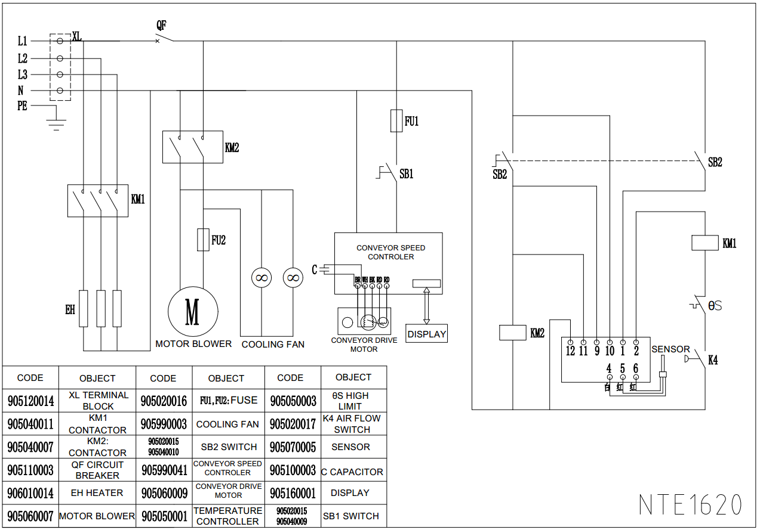

CPZ16

# 6. TROUBLESHOOTING

This section provides an easy reference guide to some of the common problems that may occur during the operation of this equipment. The troubleshooting guides are intended to help correct, or at least accurately diagnose, problems with this equipment. Although the chapter covers the most common problems reported, you may encounter problems that are not covered.

|  |  |  |
| --- | --- | --- |
| Symptom | Possible reason | Approach |
| Oven cannot be turned on | The power supply may not be delivered to the oven, or the controller may not be set correctly | -Check whether the air switch or fuse switch is on.  -Check whether the fan heating switch is on "I". The oven will not heat up until it is turned on. |
| The oven won't heat | The controller may not be set correctly. | -Check if the settings are correct  -Check if the set temperature is above 200 ° f (93 ° C). |
| The oven temperature is abnormal during normal operation. | the oven temperature is over 360 ℃ | Shut down the oven according to the daily shutdown steps. Contact your repairer authorized by manufacturer |
| Temperature CTL screen displays “SERR” error | Probe failed | Replace damaged probe; |
| Speed CTL displays “Eorr” | Motor overload | Check whether the conveyor belt is jammed, shut down and restart. |
| Fan does not rotate | Action of overcurrent protector | Check whether the fan is stuck and reset the overcurrent protector |
| Products are overcooked or undercooked | The CTL settings may not be correct | Check whether the setting of temperature and cooking time is correct |