**Hot-air Circulation Electric Oven**

**YSD-6AJ**

**User’s Manual**

**Dear Client & User,**

Thank you for choosing our products. All the information and instructions in this manual take into account standard safety regulations, current levels of technical engineering as well as the expertise and experience we have developed over the years.

If the delivery consists of a special model, the actual scope of delivery may differ from the descriptions and illustrations in this manual. This is also the case for special orders or when the device has been modified in line with new technology. Should you have any questions, please contact the manufacturer.

For safety purpose and efficient operation, please read the manual carefully before any operation to the appliance, especially when starting up the device. Install the machine in accordance with this manual and the local related rules.

Please notice that this manual is not applicable for those who have physiological, perceptual or psychological barrier or disability, as well as those who are lack of necessary knowledge or experience, including children.

**Notice: Read the instruction manual carefully before using the device. The manufacturer does not accept liability for any damage or malfunction resulting from not following the instructions for use.**

The instruction manual should be kept near the device, easily accessible for anyone wishing to work with or using it. We reserve the right to make technical changes for purposes of developing and improving the useful properties.

 **Warning**

* Any self-modification, wrong installation, adjustment or maintenance can lead to property loss or casualty. Please contact the manufacturer for any adjustment or maintenance, and have the work done by a trained & qualified personnel.
* For your safety sake, please keep the machine away from any flammable or explosive liquid, gas and other object.
* The device is not intended for use by individuals (including children) with physical or mental disabilities, insufficient experience, and/or insufficient knowledge unless such persons are under the supervision of a person responsible for their safety or have received instructions regarding appropriate use of the device.
* Keep children away from the device.
* Preserve this manual safely. When passing on/selling the device to a third party, the manuals must be handed over along with the device. All users must operate the device complying with the user’s manual and related safety guidelines.
* Do not store or use any flammable or explosive liquid, gas and other objects near the device.
* If this appliance is placed near walls, partitions or kitchen furniture and the like, it is advisable to make these facilities with non-combustible material, otherwise cover them with non-combustible heat-resistant material, and pay attention to fire prevention regulations.
* The device enclosure must be grounded to ensure safety. Thank you for your cooperation in advance.

**Contents**

1. **Functional Introduction…………………………………….****5**
2. **Structure Diagram & Working Principle…………………5**
3. **Basic Features & Parameters……………****………………..7**
4. **Precautions & Recommendations……..…………………7**
5. **Using Instructions………………………….………………..****9**
6. **Routine Check……………………………………………****…...10**
7. **Cleaning & Maintenance…………………………………….11**
8. **Failure Analysis &Trouble Shooting……………………....12**
9. **Functional Introduction**

This product is designed under our research & development while absorbing the advantages of similar products at home and abroad. It is integrated with all the merits of attractive design, reasonable structure, convenient operation, all stainless steel made, sturdy and durable, and easy cleaning, as well as temperature adjustable through the thermostat according to the food requirements within certain range. All of these features make it the ideal and necessary equipment for hotels, supermarkets, western restaurants, fast food restaurants and the like.

1. **Structure Diagram & Working Principle**

**2.1 Structure Diagram:**

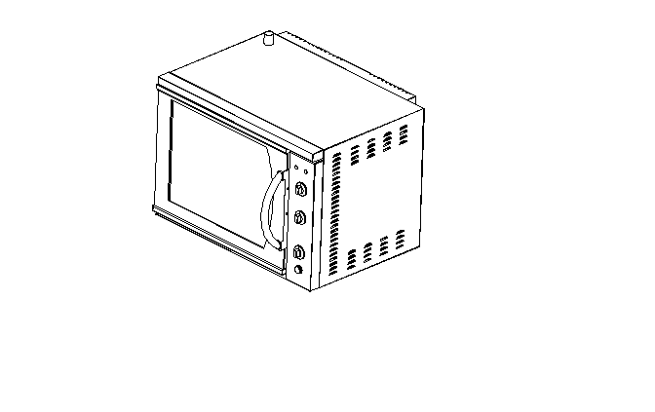

**2.2 Structural performance features**

1. It is of easy cleaning and healthy due to outer surface smoothness treatment.
2. The temperature can be regulated according to the needs and conditions of the materials.
3. It is made of stainless steel, with withdrawable stainless steel grid.
4. It has all the features of fast heating, convenient operation and easy and simple maintenance.

**2.3 Electric Diagram:**

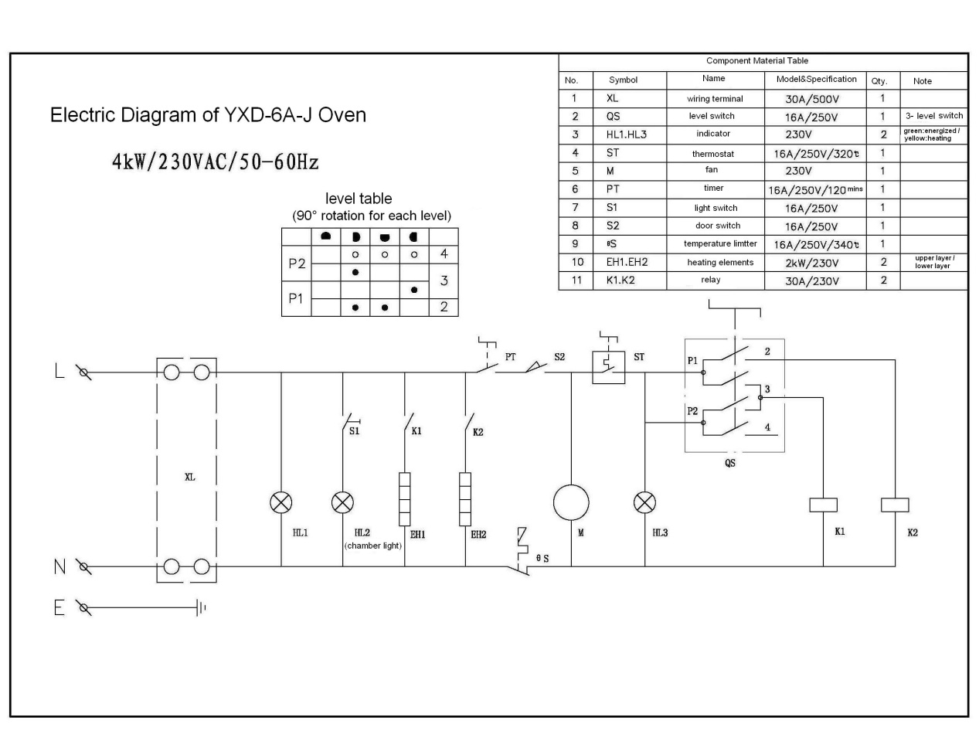

Electric Diagram of YSD-6AJ

3KW/230V/50Hz

**3. Basic Features & Parameters**

|  |  |  |  |
| --- | --- | --- | --- |
| **Model** | **Size（mm）** | **Voltage（V）** | **Power（kW）** |
| **YSD-6A** | 800×600×595 | 230 | 3 |

**4. Precautions & Recommendations**

**4.1** **Transportation and Storage:**

During transportation, please handle the appliance carefully and no upside down to prevent the damage of the enclosure and inner parts. The packaged device should be stored in a well-ventilated warehouse of no corrosive gas. Should any temporally storage needed, please take measurement against raining.

**4.2 Notice for Installment:**

**Installation:**

1. Before using, ensure that all the installation and operation are correct and comply with the local electric, healthy, and safety regulations.
2. Notice of power connection:

* Remove the package; check whether the device or its components are intact. If there’s something damaged, please contact the shipping agent and the dealer ASAP.
* Remove the protection plastic film on the side panels.
* Check for its accessories: 4 grills. If there’s anything missing, please contact the dealer soon.
* Install the legs and the handle.

1. Placement:

* Make sure that the ventilation of the motor is good. Following is the minimum distance to respect to ensure its well ventilation:

Top: 200mm; back: 25mm; left: 25mm; right: 25mm.

* Mount the oven onto the working place and employ a level gauge to ensure that all four sides of the oven are on the same horizontal level (any deviation may result in uneven baking of the food).
* When mounting, care shall be taken so that the grills and food can be easily put in and taken out.
* Caution: do not block the top ventilation point.

1. Double-layer placed:

* The 31cm legs are necessary if you want to mount an oven on another one. These legs shall be able to be secured by screws and the upper oven shall be mounted on the top the lower one, in a way that the lower one can operate normally while bearing its own weight.

1. Electric connection:

* Ensure that the device is employing the correct cords and plugs.
* Remove the back panel and connect the wiring terminals and grounding tab.
* The device must be grounded.

**Notice:**

1. The supply voltage should be in accordance with the working voltage of the device.
2. The device is equipped with grounding bolt at the back. It shall be reliably connected to ground wire that comply with the safety regulations with copper wire no less than 1.5mm².
3. After installation, check the tightness of all the connection, the correct functioning of the voltage and the reliability of the ground wire.
4. According to the wiring regulation, the fixed wiring connected to this appliance must be equipped with an all-pole disconnect switch (leakage switch), with at least 3mm contact opening distance of each pole of the switch. It is also advised to install grounded leakage protection switch. Do not pile sundries in front of the switch for convenient operation.
5. Do not store any inflammable or explosive substances near the device. The ambient temperature shall lower than 45℃ and the relative humidity shall be lower than 85%.
6. All the installation of this device should be done by professional and qualified personnel.

**4.3 Special note**

* 1. The appliance is a commercial machine which is not applicable for home use and should be operated by professional personnel.
  2. No shaking or tilting during using.
  3. Do not dismantle or modify the device, serious accidents may happen when dismantling or modifying.
  4. Do not open the appliance enclosure. The appliance contains high pressure electric circuit, electric shock may occur when dismantling the frame.
  5. Unscrew the plug and cut off the power when cleaning.
  6. Do not spray water directly to the product when cleaning. Water can conduct electricity, thus electric leakage may cause electric shock.
  7. Do not pat the product and put heavy object onto the product. Abnormal operation may cause damage and danger.
  8. High temperature may cause scald. Do not touch the appliance directly with hand due to high temperature during or after the operation.
  9. When the thunderstorm is coming, cut off the power supply asap to avoid damage done by the lighting stroke.
  10. Do not destroy the control panel with hard or sharp objects.
  11. After working, disconnect it from power.
  12. All the servicing work would be dangerous for people other than qualified personnel.
  13. If the supply cord is damaged, to avoid danger, the substitution work should be done by the manufacturer, its maintenance department or similar professional personnel.

**5. Using Instructions**

1. Check the correctness of all the power installation before using and ensure that the supply voltage complies with the working voltage of the device.
2. Connect it to power, rotate the timer to manual position, and turn the thermostat to 200℃ to heat up for 10mins ( if it is used for the first time, rinse the chamber with hot water first and then heat up for 30mins at 200℃ to eliminate the odor of the insulators).
3. Open the oven door, and put the grill with prepared food into the chamber bracket. Close the door firmly and then select the heating elements needed by the level switch, and rotate the thermostat and timer to the desired values respectively.

Caution: when open the door, the fan and heating elements in the chamber will stop working and the working indicator will turn off.

1. The internal light will be on when pressing down the light switch on the control panel, in which way that you can observe the conditions of the being baked food. If the switch keeps on, the light will be on always.
2. When time is up, the device will stop working automatically and then the food can be taken out.

**Schematic presentation of the control panel:**

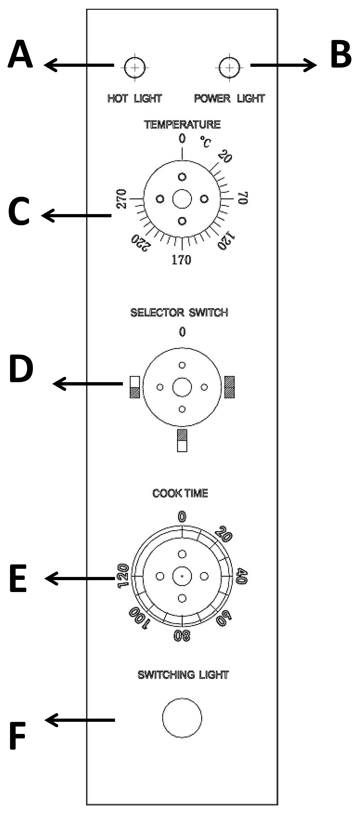

A---hot light: to display the working conditions of the heating elements.

B---power light: to display its connecting with power

C---thermostat: to control the chamber temperature, the maximum temperature setting is 300℃

D---selector switch: to select the heating elements to work as you wish.

E---timer: to control the working time.

F---light switch: to control the on/off of the internal light.

**6. Routine Check**

It is necessary to check the machine daily.

Check the machine regularly can avoid serious accident happens.

Stop using if user feels that there are some problems in the circuit or machine.

Check the appliance every time before and after using:

Before using: Whether the machine is tilted?

Whether the control panel is damaged?

Whether the power cord is aged, broken or damaged?

During using: Whether there is strange smell, odour or vibration noise?

Whether the thermostat cannot work?

Whether the power is normal?

**7. Cleaning & Maintenance**

1. Disconnect power supply before any cleaning and maintenance to avoid electric shock.
2. This device is not water resistant. Do not spray water to any parts of the device.
3. External: clean it with suitable cleanser. Hard, abrasive or corrosive cleanser may scratch the oven surface.
4. Internal: ensure that the chamber has cooled down when cleaning. Do not use a wire brush, steel wool or other abrasive and corrosive materials to wash the inner side. It is advisable to use suitable detergent. Care shall be taken in order not to damage the fan or the conduit on the right hand of the oven which is used to control the thermostat.
5. Grills: to remove the grills, slide the grill out of the top first, and then lift up the front edge and take it out upwards.
6. Side guard plate: unscrew the screws (rotating anticlockwise) so that the fender bracket is onto the oven wall. Sway the bracket towards the center of the oven to detach the screw(s) at the front edge and then draw it forward, the bracket will be removed. When put it back, mesh the bracket to the rear hole, sway it towards the oven edge to mesh the front hole, then screw back the screws.
7. Lid of the bottom heating elements: take out the lid of the glass ceramic unit, and then clean it completely. (it is suggested at least once a week)
8. Fan baffle: loosen the glass of the light and then take out the baffle. When put it back, put the bottom edge of the baffle onto the terminal panel of the bottom heating elements, then secure the glass of the oven. Do not screw tight the light glass.
9. The oven decals: when removing the decals, hold the center point tightly and then draw it outwards. Remove the side decals and then the upper and lower decals. Wash them in the water trough without damaging them. When put them back, align the openings with the oven door, mount the upper and lower decals and then the side decals.
10. Oven door glass: clean it with a general glass cleanser.

**8. Failure Analysis & Trouble Shooting**

**FAQs about electric oven:**

|  |  |  |
| --- | --- | --- |
| **Symptoms** | **Causes analysis** | **Solutions** |
| Leakage protective device trips | Electric components leakage | Find out the leakage part, repair or replace it |
| Heating time is too long | 1.the supply power is too low  2.the power fuse is burnt out  3.fans or heating elements defective | 1. Replace the fuse  2. Replace the fan or heating elements |
| No heating or heats without stop | 1.the thermostat is malfunctioning  2.the level switch failure  3. the door is not well closed | 1.repair or replace the thermostat  2. repair or replace the level switch  3. close the door tightly |
| The fans do not work | 1.motor defective  2.limit switch defective | 1. repair or replace the motor  2. replace the limit switch |
| The oven light does not work | 1. the light switch hasn’t been turned on  2. the bulb defective | 1. press down the switch, the light will turn on  2.replace the bulb |

Aforementioned troubles are just for reference. If any failure occurs, please stop using, and inform the professional technicians to check and repair.