Gas Countertop Griddles
Operating Instructions
(Flame out protection/ Electronic lighter)

Before you begin, please read these instructions carefully to use this product correctly, to make the product perform ideally, and to avoid hazards.

Models: ATMG-24P / ATMG-36P / ATMG-48P
Dear customers and users：
Thank you for purchasing our products. In order to be able to better use this product, please read these instructions carefully before any operation, and follow the guide, to avoid any unnecessary trouble during using.
Please keep this instruction manual in a safe place for convenient reference and operation.
This instruction manual is subject to any change without further notice, and the manufacturer reserves the right of final interpretation.

The appliance is designed for commercial purposes, not for household use.

This appliance is only for professional use and that it shall be used by qualified people

A statement instructing the purchaser to post in a prominent location instructions to be followed in the event the user smells gas. This information shall be obtained by consulting the local gas supplier.
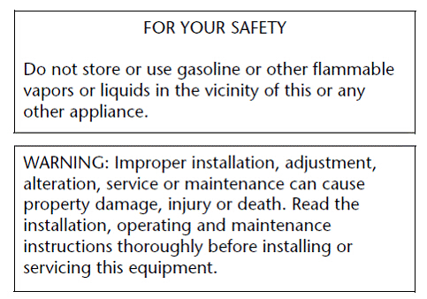

Gas Countertop Griddles
The Installation, Operation and Maintenance Guide

Contents
1. Safety Protection - 3 -
2. Brief Instruction - 3 -
3. Manufacture’s Authority and Responsibility - 3 -
4. Parameter Specifications - 4 -
5. Transport and Storage - 6 -
6. Installation and Debugging - 6 -
7. Safety Notices and Precautions - 8 -
8. Operating Instructions - 9 -
9. Cleaning and Maintenance - 11 -
10. Troubleshooting - 13 -

1. Safety Protection
- Please make sure that the operator is an authorized and licensed technician before you allow him/her to install and operate the products. Be sure to strictly follow this instruction guide during installation and using. The manufacturer is not responsible for any danger or accidents caused by improper operation or maintenance.
- Do not store flammable or explosive objects around the product. Keep all flammable and explosive objects at a safe distance away from the product for normal using.
- Place the product in a reasonable position. Regarding related matters of gas, customers should execute the requirements of local gas supply sector;
- If you smell a gas leak, turn off the gas valves immediately and call the gas company;
- The product should not be operated by those under 18 years of age, or those with physical or mental disorders, or disabilities that lack the necessary knowledge or experience unless with appropriate instructions and sufficient safety.

2. Brief Instruction
The product is a series of gas griddles in our company production, which is novel designed, reasonable structured, convenient operated, durable used, and convenient maintained. It's equipped with a high efficiency stainless steel tubular burner, combining flame out protection device and Piezo Igniter, and convenient to ignite the main fire burner.This is hotel, supermarket, western restaurant, noshery and food industry's ideal grilled product equipment.

3. Manufacture’s Authority and Responsibility
Banning of all or partial transformation to the products without the manufacturer's explicit authorization.
Manufacturers refused to undertake responsibility to third parties as the following reasons:
- Not follow this instruction guidance and warning in using and testing;
- Not in accordance with the requirements of technical parameters using this product;
- Incorrectly or irrationally using the product by untrained personnel;
- Not obey the local law using this product;
- Be repaired or changed by unauthorized technicians;
- Use the spare parts or accessories provided by non-manufacturers;
- Accidents caused by force majeure;
- Not strictly comply with related guide of instruction by any reason.

4. Parameter Specifications
4.1、Outline Dimensions(mm)
ATMG-24P
ATMG-36P
ATMG-48P
4.2、Information of Gas Supply and Burner
The external thread of product’s intake-tube is 3/4 inches.
<Table 1>
Item name | Griddle
Country of destination | Category | Gas | Supply Pressure  (mbar) | Manifold pressure  (mbar)
BE, CH, CY, CZ, ES, FR, GB, GR, IE, IT, LT, LU, LV, PT, SK, SI. | I_{3+(28-30/37)} | G30/G31 | 28-30 /37 | 25
BE, CY, DK, EE, FI, FR, HU, IT, LT, NL, NO, SE, SI, SK, RO, HR, TR, BG, IS, LU, MT | I_{3B/P(30)} | G30 | 30 | 25
PL | I_{3B/P(37)} | G30 | 37 | 25
AT, CH, DE, SK | I_{3B/P(50)} | G30 | 50 | 25
AT, BG, CZ, DK, EE, FI, GR, HR, HU, IS, IE, IT, LV, LT, NO, PT, RO, SK, SI, ES, SE, CH, TR, GB | I_{2H} | G20 | 20 | 10
DE, LU, PL, RO | I_{2E} | G20 | 20 | 10
BE, FR | I_{2E+} | G20 | 20 | 10
<Table 2>
Model | #of burners and control method | Gas Species | Nominal Rate | Reduce rate | Ignition rate | Total  Rate | Nozzle (mm)
ATMG-24P | 2 pieces  Independent control | Natural Gas | 7.0kW  (0.74m³/h) | 3.0kW  (0.32 m³/h) | 0.25kW | 14 kW  (1.48m³/h) | 2.40
ATMG-24P | 2 pieces  Independent control | L.P. Gas | 7.0kW  (552g/h) | 3.0kW  (237g/h) | 0.25kW | 14 kW  (1104g/h) | 1.45
ATMG-36P | 3 pieces  Independent control | Natural Gas | 7.0kW  (0.74m³/h) | 3.0kW  (0.32 m³/h) | 0.25kW | 21kW  (2.22m³/h) | 2.40
ATMG-36P | 3 pieces  Independent control | L.P. Gas | 7.0kW  (552g/h) | 3.0kW  (237g/h) | 0.25kW | 21kW  (1656g/h) | 1.45
ATMG-48P | 4 pieces  Independent control | Natural Gas | 7.0kW  (0.74m³/h) | 3.0kW  (0.32 m³/h) | 0.25kW | 28kW  (2.96m³/h) | 2.40
ATMG-48P | 4 pieces  Independent control | L.P. Gas | 7.0kW  (552g/h) | 3.0kW  (237g/h) | 0.25kW | 28kW  (2208g/h) | 1.45

5. Transport and Storage
In the process of transportation, handle carefully and keep upright to prevent damage of the product packing. Wrapped equipment should not be in open air for a long time, and shall be placed in a well-ventilated and non-corrosive gases warehouse. When equipment needs temporary storage, waterproof measures should be taken.

6. Installation and Debugging
- Any erroneous installation, adjustment, refit, overhaul or maintenance may cause property damage or personal injury. The work shall be performed by authorized and licensed technicians, otherwise the manufacturer has the right not to provide warranty service;
- Only be installed in accordance with the local gas, electricity and other relevant codes.
- A qualified installer should be called in to install the appliance. The appliances are to be installed with sufficient ventilation to prevent the occurrence of unacceptable concentrations of substances harmful to health in the room in which they are installed.
- The gas supply tubing or hose shall comply with the national requirements in force and shall be periodically examined and replaced as necessary.
- The lava stones provided with the appliance must be used.

6.1、Unpacking and Installation
- Please dispose of all packaging materials and residues after unpacking;
- Check the equipment. If it is damaged, please keep wrappers and receipts which must be signed by the carrier representative (Driver), and contact the carriers to pursue a claim within 15 days after receiving;
- Be sure to install supporting legs before using, and do not tear up any label or logo before normal using;
- Please read these instructions carefully before installation and operation. Please contact your local agent if you have any questions;
- The equipment shall be installed on a level, solid, non-skid and incombustible surface, and placed in a well-lighted work area with waterproof, and stay away from children and customers;
- The installation position is a well-ventilated place in accordance with the local regulations;
The char broiler must be installed under the matched cooking fume exhauster according to the local regulations;
- Important: Installation and ventilation laws, and codes are very different, you should state and comply with all codes of the local competent departments when it comes to requirements for installation of equipment;
- Screw 4 adjustable stainless steel legs in the tapping hole at four corners of the char broiler bottom, ensure sufficient space for ventilation;
- Adjustable stainless steel legs to make the equipment level, and get the same level with other series of the equipment; Please lift the equipment rather than drag if you need to move it;
- Supplied gas pressure regulator is factory set at 1kPa for Natural Gas and 2.5kPa for L.P. Gas;
- The equipment can only be placed on the incombustible counter top, and keep a distance at least 350mm to equipment’s both sides and back, and keep a distance at least 100mm to the bottom;
- Do not put anything around the equipment, and on the counter top and bottom, in order to avoid influencing combustion and air circulation;
- Leave enough distance in front of the equipment to take apart the control panel. All major parts, in addition to the burner remove from the front intake-tube;
- It may be necessary to adjust the balance of air input by authorized and licensed technicians;
- Thread glue must be resistant to the action of liquefied petroleum gases.
- Warning! Use soap water or testing instrument to test whether piping joint leaks or not before using, and forbid using an open flame to test!
- After installing completely, you should check gas supply pressure. Use a pressure gauge which is equipped with liquid (such as U-type pressure gauge, the minimum value is 0.1mbar) or a digital pressure gauge to test. Steps are as following:

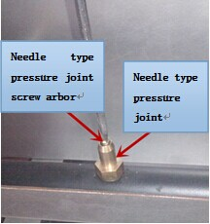
●Remove top panel, and needle type pressure joint screw arbor (Fig.1), then slip rubber tube of pressure gauge over needle type pressure joint;
●Start the equipment in accordance with the instructions, measuring gas supply pressure (dynamic pressure) in the work state;
●Access to the equipment if measured data within the limits of Table 1, otherwise, you will need to adjust gas pressure
regulating valve or contact gas supplier to bargain; Fig.1
●Unplug pressure gauge after you accomplish pressure testing, then install needle type pressure joint screw arbor. Important: make sure screw up the needle valve to prevent gas escape!

6.2、Debugging
It’s very important to debug the new stove. Through the comprehensive system test of equipment, we can ensure function and safety performance of products. Discovering any potential problems before use (such as equipment’s placement, ventilation, operation, etc), can avoid costly losses.

7. Safety Notices and Precautions
- Warning! For your safety, do not place petrol and other flammables nearby. Please keep clean and free of flammables surroundings.
- Warning! Any erroneous installation, adjustment and refit may cause property damage or personal injury and maintenance failure. Read the instructions carefully before installation and using.
- Warning! Operation instruction must be placed in a conspicuous location. When customers smell gas in the process of using, you should take safety precautions immediately. Immediately turn off the main gas valve, extinguish all heat and flames. Safety information can be obtained from your local gas suppliers.
- DO NOT SPRAY AEROSOLS IN THE VICINITY OF THIS APPLIANCE WHILE IT IS IN OPERATION.
When using this equipment, safety precautions should always be followed, including the following:
- The griddles burners, grates and outside surfaces may become hot after using, so you must be careful to touch;
- During operation, do not directly touch burners and plates;
- Turn off the equipment as not in using, cleaning, servicing or adjusting any parts or attachments.
- If the equipment has any problems of equipment damage, gas piping leaks, igniter or valves damage, or lose product accessories, do not operate by yourself and call for the service immediately;
- The attachments not recommended or sold by the manufacturer may cause fire, personal injury, even death;
- Do not use out of doors;
- The equipment is used for grill, not available for any other using;
- The equipment does not contain any user-serviceable parts. Dealers or technicians will repair it. Do not take apart any spare parts without authorization;
- Never change any other parts without authorization to this equipment, otherwise, may cause hazards, and the manufacturer has the right not to provide warranty service;
- Steel cutting producers used to manufacture with sharp edges. The manufacturer has dealt with these sharp edges during production, however, we insist the operator take care when in contact with this piece of equipment;
- Always keep hands, hair and clothing away from heating source.
- Wait the unit cools down before you cleaning. Because the unit is too hot to handle after using.

8. Operating Instructions
- Before operating, make sure place the unit horizontally by adjusting bottom adjustable legs, and place the catch tray properly.
- To ensure that the air flow in the bottom of the equipment.
- Do not use a fan or air conditioning to the flame, so as to avoid the flame extinguished and a safety accident.
- Must be installed the matched exhaust hood according to the local regulations above the equipment.
- To ensure that the air in the kitchen is kept in circulation.
- The pilot light has been set at the factory. Each burner has a pilot light.
- The minimum temperature of the solid top was about 250℃

8.1、Lighting the fire
①Align the control valve knob on the "O" position (Fig.2), so that the valve is closed.
②And then axial press the front air valve knob, left 30 degrees, to the fire position (Fig.3).
③At the fire position, completely press the knob, meanwhile press the bottom of Piezo Igniter, there is electric spark between pilot and fire needle. If the fire is not lit, please repeat this action until the fire is ignited,
and observe stability of fire.

Tip: There is air in the pipeline when the first time light the fire, then can normally light the pilot light until flow out air.

8.2、Igniting the main burner

Revolve the main fire control valve knob anticlockwise after lighting the pilot light, and then the main fire burner is ignited by the pilot light. When knob reaches to " " (90 degrees), burner is in the maximum power (Fig.4). Once again axial press the knob and revolve it anticlockwise, the power of burner reduces gradually with the rotation angle increases. When knob is rotated 150 degrees to " ", burner is working with a minimum power (Fig.5).
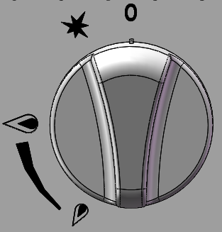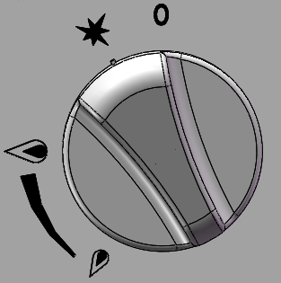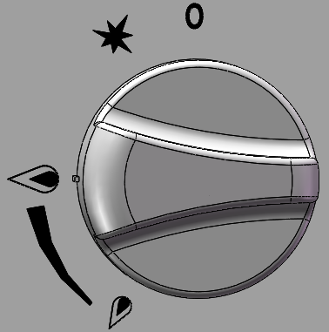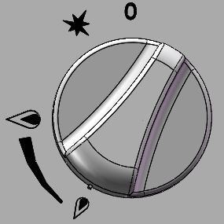
Fig.2 Fig.3 Fig.4 Fig.5

8.3、Turn off the valve
①When the control knob is rotated to the fire position(Fig.3), the main fire burner flame is extinguished, but the pilot light will continue to work.
②Axial press the knob to rotate knob clockwise continually, so that the direction of the knob on the "O" position, at this time, the fire extinguished, the valve closed.

8.4、Stove Operation
Before using the stove for the first time, please use a mild detergent to wipe it for cleaning. Do not use corrosive or abrasives detergent.
Turn the burners on about 15-20 minutes before broiling for preheating, according to the cooking requirement to adjust the flame size.
Notice: Before first preheating, the furnace will smoke rise. This is because of protective lipids on the grills and other parts are heated, it is normal, and it will be eliminated after the power up to the maximum for burning an hour.

8.5、Exchange main fire nozzle to switch gas source
Remove the control panel, grill, fire seat, and bottom tightening screw of the end of burner (arc), take out burner, then remove main fire nozzle with proper open spanner, exchange nozzle of another gas source, then screw it. Reinstall burner, fire seat, grill and the control panel in proper place.
- Caution: Each main fire nozzle of the burner has been installed before delivery, normal use without adjustment but only switching gas. Adjust only by authorized and licensed technicians. When you change the gas source, you need exchange the corresponding pressure maintaining valve and fire seat which installed on air intake.

8.6、Adjust air input
Remove the control panel, grill, fire seat, and bottom tightening screw of the end of burner (arc), take out burner, adjust an appropriate opening degree according to the need, then tighten the damper fastening screws, to ensure the equipment will not get loose in the process of moving and translation. Reinstall control panel.
Caution: Each burner damper has been adjusted before delivery (once air input), normal use without adjustment but only switching gas. Adjust only by authorized and licensed technicians.

9. Cleaning and Maintenance
- Do not use any abrasive or flammable detergent to wipe;
- Do not hose down, immerse or pressure wash any part of the cooker, excluding the catch tray;
- Do not use abrasive cleaning matters to wash, even not use corrosive detergent!
- Grill cleaning/maintenance:
- when grill cools down, use a cloth with cleaning agent to wipe unit surface and residue;
- use a cloth with water to wipe unit surface;
- burning the main fire burner about 10-20 minutes for sterilization;
- no use for long time, spread cooking oil on grill after cleaning.
- Warning: Before cleaning, all control valves must be turned off. Strictly follow the lighting instructions to work again after cleaning!
- Warning: Wait for the equipment to cool down after the unit has been turned off before you cleaning!
- Cut off the gas source as not in using;
- If the equipment is not used for a long time, clean the surface by wiping it with a soft cloth and place it in a well-ventilated area;
- Comprehensively check the equipment at least once every year by authorized and licensed technicians;
- The product is made of 90% metals, and can not be discarded everywhere. Deal with it in accordance with the local codes.
- Instructions to clean appliance regularly with recommended cleaning agents, if necessary.

Recommended cleaning methods

<Table 3>
Items | Methods | Times
Body | Wipe it with a soft cloth and mild detergent; | daily
Control panel | Turn off valves when not in use;  Wipe panel and control valve knob with mild detergent. | daily
Catch tray | Pull out catch tray from front body until the equipment cools down. Clean grease and other crumbs. Reinstall after cleaning.  Warning: if the catch tray is permitted to fill too high, should be cleaned! | Per use

10. Troubleshooting
<Table 4>
Problems | Possible causes | Problem solving
Not lighting | 1.Insufficient gas pressure in pipe | 1.Contact the local gas supply dept.
Not lighting | 2.Nozzle occlusion | 2.Dredge nozzle
Not lighting | 3.Thermocouple connection loose | 3.Tighten the thermocouple
Not lighting | 4.Thermocouple damage | 4.Replace thermocouple
Not lighting | 5.Gas control valve failure | 5.Replace gas control valve
Ignite the pilot light but not the main fire | 1.Insufficient gas pressure in pipe | 1.Contact the local gas supply dept.
Ignite the pilot light but not the main fire | 2.The main fire nozzle occlusion | 2.Dredge nozzle
Ignite the pilot light but not the main fire | 3.Gas control valve failure | 3.Replace gas control valves
Close gas and heard a sound of fire | 1.Insufficient gas pressure in pipe | 1.Contact the local gas supply dept.
Close gas and heard a sound of fire | 2.Not match nozzle aperture with gas resources | 2.Adjust nozzle diameter
Close gas and heard a sound of fire | 3.Flow of connection pipe is not enough | 3.Increase pipe’s allowable flow
Close gas and heard a sound of fire | 4.Damper opening degree is too large | 4.Adjust damper
Yellow flame and black smoke | 1.Use the gas of bottom | 1.Replace gas
Yellow flame and black smoke | 2.Not match nozzle diameter with gas resources | 2.Adjust nozzle diameter
Yellow flame and black smoke | 3.Not enough air to ignite | 3.Increase damper opening degree
Yellow flame and black smoke | 4.In the peak of using gas, sources of gas float heavy | 4.Turn down valves flow. Turn it up after the peak

The problems mentioned above are only for reference. If any fault occurs, please stop using, and contact technicians to check and repair. Safety first, turn off the power and gas supply before maintenance.

Notice：
- Pressure maintaining valve connects with air intake must be installed by authorized and licensed technicians to ensure interface tightness.
- When the regulator is connected, the maximum load value of natural gas can not exceed 1.13kPa, the maximum value of liquefied gas can not exceed 2.75kPa.
- Screw the hex nut (Fig.6) before connect air intake, ensure gas mark (Fig.7) on the plastic core match with connected gas source, if not, then pull out the plastic core and change another head, insert it again. The same as exchanging gas source.
- When exchange gas source, unscrew the hex nut(at the bottom of fire seat) first(Fig.8), then adjust adjusting screw rod(Fig.9) with a screwdriver to meet the normal requirements of pilot light flame.
NOTICE: Each fire seat has been adjusted before delivery, normal use without adjustment and exchange. Only replace it when converse gas source, and operate by qualified professionals.
- The A18 orifice in the accessories used in the replacement of the gas resource. Follow rules of 8.5.
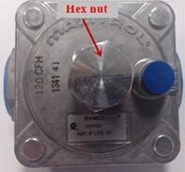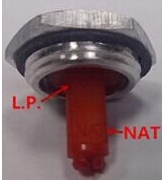
Fig.6 Fig.7
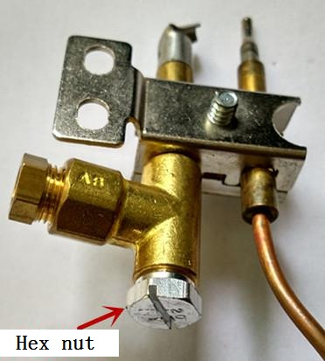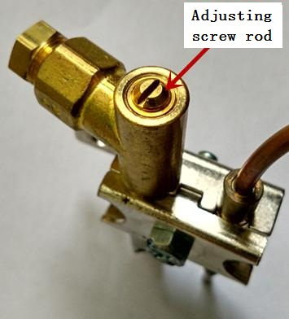
Fig.8 Fig.9

0359-20
PIN Number: 0359CQ00667
BSEN 203-1:2014 / EN 2003-2-4:2005
Gas catering equipment (Type A)

Our products have the advantages of good durability and low maintenance charge. But to update some components and necessary maintenance, can prolong life length of the products. Contact the dealer for assistance.

