ELECTRIC CONVEYOR TOASTER
USER’S MANUAL

Adjust the speed of conveyor to control the color of toasting bread. The feed ramp can lead bread on to the conveyor. The toast crumb tray collect crumb easily. The front and rear discharge can be changed to use by mind. To ensure proper operation, please read this manual carefully before using. After reading, keep this manual in a convenient place for further reference.

- Technical Parameter

Model | CT-1 | CT-2 | CT-3
Voltage(V) | 220-240 | 220-240 | 220-240
Power(W) | 1340 | 2240 | 2640
Frequency(Hz) | 50/60 | 50/60 | 50/60
Dimension(mm) | 288×418×387 | 368×418×387 | 468×418×387
Efficiency (pcs/h) | 150 | 300 | 450

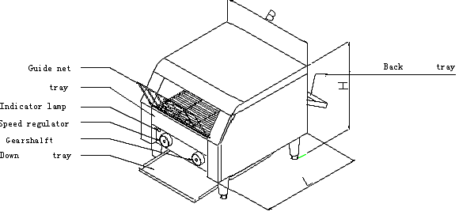

2、Additional parts installation
2.1、When the package was opened, get the above additional parts as follow: one down tray、one back tray、one guide net and four adjustable feet.
2.2、First, install the four adjustable feet into the nuts which at the bottom of the unit body. Then places the unit at the proper counter height, in order to safety operation, adjusts the adjustable feet to make the unit placed staidly.
2.3、Insert the hook of the crumb tray meets the stop pins as picture one showing.
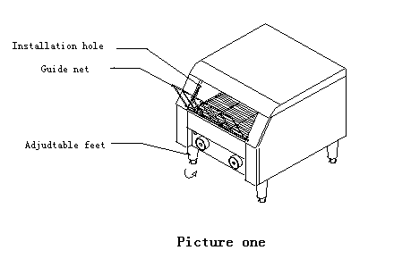
2.4、Down tray installation: hanging the down tray to the hook of the down tray following the arrowhead (picture two).
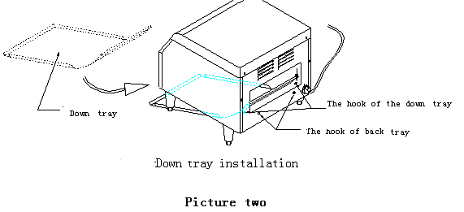
2.5、Back tray installation: hanging the back tray to the hook of the back tray following the arrowhead (picture three).
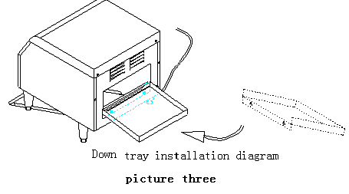
3、 Electricity installation
3.1、Make sure the supplied voltage is coordinated with the using voltage.
3.2、The power wire should be connected the special socket which lead through the special air switch and the electric leakage protector. Make sure the ground wire connection is connected well. For convenient operation, ban to pile up the sundry goods near the switch.

4、Operation
4.1、When the power is on the indicator will light, turn the knob COLOR CONTROL to right until it reached the position “3”(notice: the speed of the chain net as fast as the color became lighten. When the gearshift switch was turned to the “BREAD” position, the up electric heating tube and the down electric heating tube will heating at the same time, and the inside temperature of the unit will warm up. The temperature in the middle of the unit can be reached the highest temperature 284℃ in twelve minutes, if there was no bread inside of the unit. Then the temperature will stay in 284℃.
4.2、Before toasting, turn on the power and approximately 10 to 12 minutes for a warm-up period. Then try to toast two pieces of bread to see whether the color is good or not, and adjust the speed of the chain net. If want the color deepen, turn the color controller to right to go over “3” position. (Notice: the more graduation and lower chain net speed, the color of the bread will deepen. As the visa.) After adjusted the speed of the chain net, put the bread into the chain net follow the tray. The bread will go with the chain net into the inside of the unit and toasting in the inside of the unit.
4.3、After finished toasting, put the bread into the down tray, the bread will follow the down tray to slip to the front from the unit chamber as picture four showing.
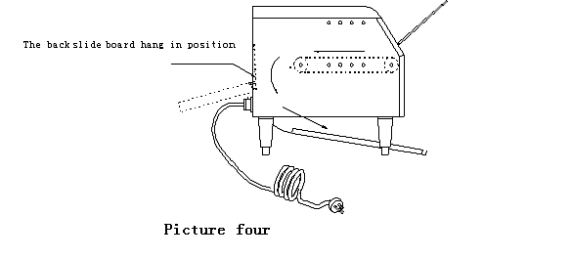
4.4、If want to get the bread from the back of the unit, there was no back tray installed in, just need to press the back slide which with a pull ring in the back of the unit, make the back slide board hook meets the pin which near the chain wheel. The toasted bread will follow the back slide board to slide to the back tray as picture five showing. Pull the pull ring and let the back slide board recover after finished.
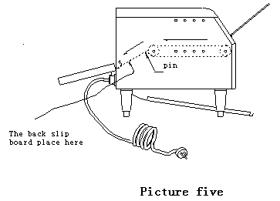
4.5、If toasting the steamed bun, turn the knob which in the right to the “BUNS” position, the up electric heating tube working on. If want to heat preservation, turn it to the “STBY” position.
4.6、After finished working, turn the knob to “OFF” position and pull the plug out.
4.7、If the wire was damaged, replace it by the manufacturer or service agent and the qualified person only, in order to avoid dangerous.

5、Clean and maintenance
5.1、when clean and maintenance the unit, cut-off the power in case of accident.
5.2、After finished a day’s work, pull out the tray and clean it. Use the soft wet towel that has not corrosive clean preparation to cleaning the unit. Do not wash the unit with water jets.
5.3、To prevent the unit to be polluted and effect the unit’s function, do not use the unit to toast the food that content too much sugar in the surface or the food will flow and stick after heating.

6、Circuit diagram
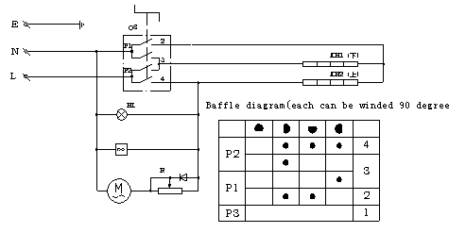
HL1----- Power indicator lamp ∞------Fan EH1，EH2------Electric heating tube
R------Speed regulator M------Motor QS------Switch
7、Decomposition diagram
8、Spare parts
No. | Name | Model & Specifications |  |  | Amount
No. | Name | CT-1 | CT-2 | CT-3 | Amount
1 | Wire | 3×1.0m㎡ | 3×1.5m㎡ | 3×1.5m㎡ | 1
2 | Indicator lamp | 250V Green |  |  | 1
3 | Winding resistor | 30W 800Ω |  |  | 1
4 | Switch | 4924015000 |  |  | 1
5 | Fan | SF23080AT | DP200A | DP200A | 1
6 | Motor | QXYH6030M23G |  |  | 1
7 | Down electric heating tube | 230V 0.6kw | 230V 0.9kw | 230V 1.2kw | 1
8 | Up electric heating tube | 230V 0.7kw | 230V 1.0kw | 230V 1.4kw | 1

