Electric Contact Grill

User’s manual

Thanks for your purchasing and using Electric Contact Grill. For making full use of function of this product and reducing unnecessary damage and injure. Please read this manual carefully before using this machine and keep it well for future reference.

Warning! Any refitting and wrong installation, adjustment and maintenance can lead to property loss and causality. Please contact the supplier if user needs to adjust it and all these should be done by trained special professionals.

Warning! For your safety sake, do not put or store any flammable liquid, gas or other objects around the product.

Warning! The shell of this equipment must be grounded for safety sake. Thanks for your cooperation!

Electric Contact Grill is designed and developed by the company with combination of the advantage of both foreign and domestic similar products and achieves advantages such as fashionable design, reasonable structure and convenient operation and maintenance and durability. The temperature of the griddle pan can be regulated in a certain scale according to different cooking requirements. Mainly used for grilling the beef of sandwich and also for other food, it is the first choice for the food industry enterprises such as western food restaurants, fast food restaurants, hotels and supermarkets and etc.

Exterior Structure

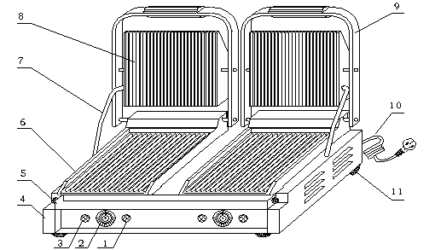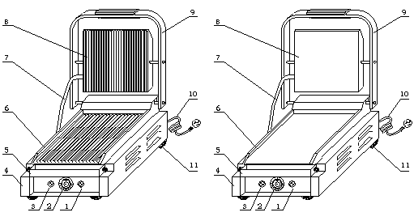

1—HEATING INDICATOR 2—TEMEPRATURE CONTROLLER
3—POWER INDICAOTR 4—BOTTOM BOX
5—OIL TRAY 6—LOWER MODULE PLATE 7—FEED WIRE TUBE 8—UPPER MODULE PLATE 9—OPERATION HANDEL 10—POWER CORD 11—RUBBER FEET

Features of Function and Structure
  - The upper and lower module plates are enameled and are easy to be cleaned.
  - One-headed and double-headed grilling pans can be chosen freely.
  - Independent temperature controlling system are convenient to handle and can achieve energy economy as well.
  - Internal temperature protector is reliable and safe.
  - Grilling temperature can be adjusted according to different requirements.
  - It is made by stainless steel and the drawer-style oil tray is also made of stainless steel.
  - It is easy to lift up and down and convenient to handle and maintain.

Basic Parameter
Name | Contact Grill single Upper/lower ribbed | Contact Grill single Upper/lower smooth | Contact Grill single  Upper ribbed/lower smooth |  | Contact Grill single Upper/lower ribbed | Contact Grill single Upper/lower smooth
Model | PG-SA | PG-SF | PG-SC |  | PG-MA | PG-MB
Voltage | 220~240V  50/60Hz | 220~240V  50/60Hz | 220~240V  50/60Hz |  | 220~240V  50/60Hz | 220~240V  50/60Hz
Power | 1.8KW | 1.8KW | 1.8KW |  | 2.2KW | 2.2KW
Temperature controller number | 1 | 1 | 1 |  | 1 | 1
Temperature range | 50~300℃ | 50~300℃ | 50~300℃ |  | 50~300℃ | 50~300℃
Upper grill size | 214×214(mm) | 214×214(mm) | 214×214(mm) |  | 340×220(mm) | 340×220(mm)
Lower grill size | 218×230(mm) | 218×230(mm) | 218×230(mm) |  | 360×285(mm) | 360×285(mm)
Dimension | 290×395×210(mm) |  |  | 410×370×220(mm) |  | 410×370×220(mm)
Weight | 13kg | 13kg | 13kg |  | 15.5kg | 15.5kg

Name | Contact Grill single  Upper ribbed/lower smooth | Contact Grill double Upper/lower ribbed | Contact Grill double  Upper/lower smooth | Contact Grill double  Upper ribbed/lower smooth | Contact Grill double  Upper smooth/lower ribbed
Model | PG-MC | PG-2SA | PG-2SF | PG-2SC | PG-2SD
Voltage | 220~240V  50/60Hz | 220~240V  50/60Hz | 220~240V  50/60Hz | 220~240V  50/60Hz | 220~240V  50/60Hz
Power | 2.2KW | 3.6KW | 3.6KW | 3.6KW | 3.6KW
Temperature controller number | 1 | 2 | 2 | 2 | 2
Temperature range | 50~300℃ | 50~300℃ | 50~300℃ | 50~300℃ | 50~300℃
Upper grill size | 340×220(mm) | 214×214(mm) | 214×214(mm) | 214×214(mm) | 214×214(mm)
Lower grill size | 360×285(mm) | 475×230(mm) | 475×230(mm) | 475×230(mm) | 475×230(mm)
Dimension | 410×370×220(mm) | 570×395×210(mm)
Weight | 15.5kg | 27kg | 27kg | 27kg | 27kg

Name | Contact Grill double Upper/lower ribbed | Contact Grill double  Upper/lower smooth | Contact Grill double  Upper ribbed/lower smooth | Contact Grill double  Upper smooth/lower ribbed
Model | PG-2MA | PG-2MB | PG-2MC | PG-2MD
Voltage | 220~240V  50/60Hz | 220~240V  50/60Hz | 220~240V  50/60Hz | 220~240V  50/60Hz
Power | 4.4KW | 4.4KW | 4.4KW | 4.4KW
Temperature controller number | 2 | 2 | 2 | 2
Temperature range | 50~300℃ | 50~300℃ | 50~300℃ | 50~300℃
Upper grill size | 340×220(mm) | 340×220(mm) | 340×220(mm) | 340×220(mm)
Lower grill size | 759×285(mm) | 759×285(mm) | 759×285(mm) | 759×285(mm)
Dimension | 810×370×220(mm)
Weight | 31kg | 31kg | 31kg | 31kg

Transportation and Storage
Please handle the griller carefully and cautiously in transportation and do not turn it upside down to prevent any damage to the shell and interior. The packed griller should be stored in the storehouse ventilation and non-corrosive gas. Any weatherproof measures should be applied when temporary storage.

Notes
  - The working voltage of the equipment should match that of the power supply.
  - Suitable switch, fuse breaker and three-phase socket should be installed near the equipment.
  - There is an earth bolt at the back of the equipment. Please connect the earth wire in compliance with the safety regulations reliably with copper cable of no less than 2mm.
  - Before using user should check whether connection is firm and voltage is regular and earth connection is safe.
  - Do not put any object onto the upper module plate and shake the lift operation handle with sudden force.
  - Cut off power supply while cleaning. Do not use wet towel with corrosive cleanser and do not directly splash water on the equipment.
  - The adjustable temperature of the equipment is between 50~200℃. It is recommended that the maximum working temperature normally should be 200~250℃.
  - Do not store any flammable objects near the equipment. The environment temperature lower than 45℃, the humidity is under 85%.
  - The installation and maintenance of the equipment should be made by professional technicians.

Special Notes

WARNING!
● This product is a commercial machine and it must be operated by trained cook.
● Do not dismantle and refit the machine.
Do not lift the upper module plate with sudden force and tilted installation.
The dismantlement and alteration can cause serious accident happens.
- Before cleaning, unplug the machine and cut off power supply.
Do not spray water directly to the product.
Water can conduct electricity and electricity leakage happens.
- Do not pat the product and put heavy object onto the product.
Incorrect operation can cause the equipment be damaged and dangerous.
- High temperature will cause scald.
When the equipment is in use and before or after using it, do not touch the box and module plate because of high temperature.
● Do not use any power supply which is not coordinated with safety standards.

NOTICE!
- When the thunderstorm is coming, the electricity supply must be cut off soon.
It will avoid the equipment being damaged in cause of lightning stroke.
● Do not destroy the control panel and the surface of the machine with hard or sharp things.
● When the machine finishes using , user should close main switch.
- The installation and maintenance of circuit must be done by certificated special professionals.
If the supply cord is damaged, it must be replaced by the manufacturer or its service agent or a similarly qualified person in order to avoid a calamity.

Operation Instruction
  - Before using, check whether the power supply installation is regular to make sure the supplied voltage is coordinated with the using one.
  - Put the plug in the socket and turn on the power.
  - Turn the temperature controller clockwise to the temperature needed. The yellow indicator is on that shows heating wire begins to heat and the upper and lower griddle begins to raise temperature.
  - Temperature can be adjusted according to different food preferably within 180℃~250℃. About 8 minutes is needed for the temperature to be raised to 250℃ from the power is on.
  - When the temperature reaches 250℃, lift the upper module plate to a suitable place by operation handle. Put some edible vegetable oil on the lower module plate and constantly place the food on it. Close the plates and press the handle lightly. Keep an eye on the food until it is suitably done.
  - When temperature reaches the setting degree, temperature controller can cut off power supply automatically. At the same time, yellow indicator is off and green indicator is on. It shows that electricity heating tube stops working for next turn.
  - At the lower front of the lower module is the oil tray. Substantial vegetable oil and the animal oil from the meat grilled flow to the oil tray from the lower module plate.
  - Lift the upper module plate to take the sandwich and other food already done.
  - When the temperature is a bit lower, the temperature controller can get through power supply automatically. The heating tubes restart to work to heat the module plates.
  - On completion of the work, temperature controller should be turned to the “off” place. Unplug the equipment and cut off the power.
  - Notice: There is temperature limiter in the bottom box, the action temperature is 130℃, and reset temperature is ‹40℃. When temperature is over the protective button works for protection. When use it again, please use it after press the protective button.

Cleaning and Maintenance
  - Cut off the power supply before cleaning in case of accident.
  - Do not use wet towel with non-corrosive cleanser to clean the module plate, the surface of the equipment and power cord. Direct wash by water is not permitted in case of any damage of the functions.
  - If do not use it at any time, please turn off temperature controller and main switch.
  - Please store the equipment in a ventilated storehouse without corrosive gas after cleaning when ceasing its work for a long time.

Troubleshooting
Troubles | Causes | Solutions
1. Module plates are out of heating when the power and heating indicator are both on. | - Temperature controller is broken.  - At least one of heating wires is burned.  - Temperature protector works. | - Change temperature controller.  - Change the burned heating tube.  - Dismantle the bottom plate and use hand to reset temperature protector.
2. When the power is on and temperature controller is switched and heating indicator is on and temperature can be not controlled. | 1. Temperature controller is out of order. | 1. Change temperature controller.
3. Indicator is not on when the power is on and the heating process is normal. | 1. Indicator is broken. | 1. Change temperature controller.
The indicator is out of order when the power is on. | - Abnormal power supply or cut-off power supply.  - Fuse is burned. | - Check power supply and connection to make power supply be normal.  - Change fuse.

Aforementioned troubles are just for reference. If any fault occurs, please cease using and turn to professional technicians for check and repair.

Circuit Diagram
PG-SA PG-SF PG-SC PG-MA PG-MB PG-MC
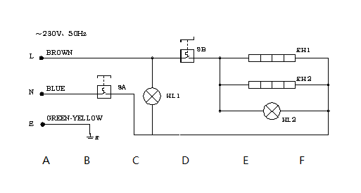

PG-2SA PG-2SF PG-2SC PG-2SD PG-2MA PG-2MB PG-2MC PG-2MD
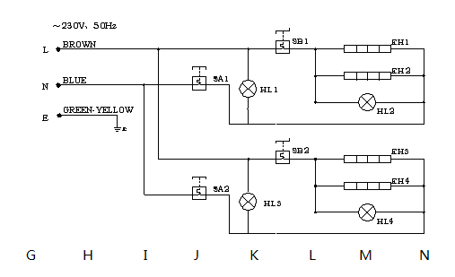

HL1, HL3----POWER INDICAOTR HL2, HL4----HEATING INDICATOR
SA, SA1, SA2----TEMPERAUTRE CONTROLLER E----GROUND CONNECTION SB, SB1, SB2----TEMPERAUTRE CONTROLLER
EH1, EH2, EH3, EH4----HEATING WIRE
THE SHELL OF THIS MACHINE MUST BE EARTH GROUNDED FOR SAFETY SAKE. THANKS FOR YOUR COOPERATION.

Daily Check
Everyday notice the situation of the machine before or after using.
Before using | Whether the machine is tilted?
Before using | Whether the power cord is old, broken or damaged?
Before using | Whether the control panel is damaged?
After using | Whether there is strange smell?
After using | Whether the upper and lower module plate cannot be heated at the same time?
After using | Is there any strange voice or is the machine out of control while the machine is lifting?

WARNING!
- Must check the machine everyday.
Usually check the product that can avoid serious accident happens.
- Stop using if user feels that there are some problems in the circuit or machine.
Ask the special technicians to check and maintain the machine as soon as possible.

K. Solid Resolution Graph

Declaration: The structures of PG-SA/PG-SF/PG-SC/PG-MA/PG-MB/PG-MC are different, the differences are: The upper and lower module plate of PG-SA and PG-MA are ribbed; the upper and lower module plate of PG-SF and PG-MB are smooth. The upper and lower module plate of PG-SC and PG-MC are upper ribbed and lower smooth.

Declaration: The structures of PG-2SA/PG-2SF/PG-2SC/PG-2SD/PG-2MA/PG-2MB/PG-2MC/PG-2MD are different, the differences are: The upper and lower module plate of PG-2SA and PG-2MA are ribbed; the upper and lower module plate of PG-2SF and PG-2MB are smooth. The upper and lower module plate of PG-2SC and PG-2MC are upper ribbed and lower smooth. The upper and lower module plate of PG-2SD and PG-2MD is upper smooth and lower ribbed.

1. HEATING INDICATOR 2. TEMPERATURE CONTROLLER
3. CROSS-HEADED SCREW M4×6 4. POWER INDICATOR
5. BOTTOM HULL 6. INTERNAL HEXAGON SCREW M6×10
7. FLAT SPACER 8. INTERMAL HEXAGON SCREW M5×25
9. FLAT SPACER 10. WISTING SPRING 11. REAR ROTARY AXLE 12. FASTONTING STAND 13. INTERNAL HEXAGON SCREW M6×40 14. BACK UPPER COVERING BOARD 15. SCROSS-HEADED SCREW M4×8 16. SPRING PIN 17. EQUIPOTENTIAL GROUND SCREW M6×15 18. POWER SUPPLY WIRE JACKET 19. POWER CORD 20. POWER GROUND SCREW M5×15 21. GRILL OF LOWER MODULE
22. UPPER MODULE BOARD 23. CROSS-HEADED SCREW M4×8 24. HEAT-INSULATED COTTON OF UPPER MODULE
25. PLATEN OF UPPER ELECTRIC HEATING TUBE 26. GRILL OF UPPER MODULE 27. ELECTRIC HEATING TUBE OF UPPER MODULE 28. INCOMING LINE TUBE 29. SPRING CHECK RING FOR AXLE 30. SPRING CHECK RING FOR TUBE 31. AXLE OF UPPER MODULE 32. INTERNAL HEXAGON SCREW M5×16 33. INTERNAL HEXAGON SCREW M6×8 34. HANDLE 35. FRAME OF OPERATION HANDLE 36. OIL TRAY 37. HALF OF CHEESE HEAD SCREW M6×12 38. SMALL BALL 39. HEAT-INSULATED COTTON OF LOWER MODULE
40. PRESSURE PLATE FOR COTTON 41. CROSS-HEADED SCREW M4×20
42. AMPHENOL CONNECTOR PLATE 43. CROSS-HEADED SCREW M4×8 44. CERMIC CONNECTORS 45. TEMPERATURE LIMITER
46. HEXAGON SCREW M6×20 47. RUBBER FOOT 48. PRESSURE PLATE FOR ELECTRIC HEATING TUBE OF LOWER MODULE
49. ELECTRIC HEATING TUBE OF LOWER MODULE 50. INTERNAL HEXAGON SCREW M6×8 51. BOTTOM BOARD 52. CROSS-HEDED SCREW M4×8

