Ⅰ.Specification
1). Item No.: BT-350K6-E / BT-350KCT-2-A
2). Power Rate: 500W - 3000W
3). Voltage: 220 -240V~ 50Hz
4). Temperature: 60℃-240℃

Ⅱ.Cautions
1). Do not plug with wet hands.
2). Do not plug into a socket where several other appliances are plugged in.
3). If the supply cord is damaged, it must be replaced by the manufacturer, its service agent or similarly qualified persons in order to avoid a hazard.
4). Do not modify the parts, or repair the unit by yourself.
5). Do not use the unit near flame or wet places.
6). Do not use where children can easily touch the unit, or allow children to use the unit by themselves.
7). Do not place on unstable surfaces.
8). Do not move the unit when the pot or the pan is on it.
9). Do not heat the pot empty or overheat the pot.
10). Do not place metallic objects such as knives, forks, spoons, lids, cans, and aluminum foils on the top plate since they can get hot.
11). Use the unit with sufficient space around it. Keep the front side and either right or left side of the unit clear.
12). Do not use the unit on carpet or tablecloth (vinyl) or any other low-heat-resistant article.
13). Do not place a sheet of paper between the pot or the pan and the unit. The paper may get burnt.
14). If the surface is cracked, switch off to avoid the possibility of electric shock and then take to the service center immediately.
15). Do not block air intake or exhaust vent.
16). Do not touch the top plate right after removing the pot or the pan, as the top plate will still be very hot.
17). Do not place the unite near to the objects which are affected by magnet, such as: radios, televisions, automatic-banking cards and cassette tapes.
18）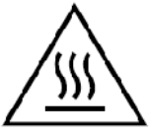 CAUTION: Hot surface.
The surface is liable to get hot during use
Do not touch the top plate right after removing the pot, since the top plate will still be very hot
19) This appliance can be used by children aged from 8 years and above if they have been given supervision or instruction concerning use of the appliance in a safe way and if they understand the hazards involved. Cleaning and user maintenance shall not be made by children unless they are older than 8 and supervised. Keep the appliance and its cord out of reach of children aged less than 8 years.
20) The temperature of accessible surfaces may be high when the appliance is operating.
21) Aluminium foil and plastic vessels not placed on hot surfaces.
22) the glass-ceramic surfaces are not to be used for storage.
23) metallic objects such as kitchen utensils, cutlery etc. shall not be placed on the hob surface within the cooking zones since they could get hot;
24) take care when operating the appliance, as rings, watches and similar objects worn by the user could get hot when in close proximity to the hob surface
25) only use vessels of the type and size recommended.
26) After use, switch the hob element off by means of its control. Do not rely on the pan detector.
27) appliance not to be cleaned with water jet;
28) any repairs shall be carried out only by persons trained or recommended by the manufacturer.
29) Appliance is not intended to be operated by means of an external timer or separate remote-control system.
30）COMMERCIAL USE ONLY.
Warning: Children should be supervised to ensure that they do not play with the appliance.
When the pot is removed, the induction hotplate can stop heating immediately and shut down after the buzzer sounds for 30 sencond.
Remind: The patient with a heart pacemaker shall use this product under the guidance of the doctor.
1. NOTE: Instructions for use may be markedon the appliance as long as they are visible innormal use.
2. The specific instructions related to the safeoperation of this appliance (as given in 7.12 ofthis standard) shall be collated together in thefront section of the user instructions. Theheight of the characters,measured on the capital letters, shall be at least 3 mm.

Ⅲ.How to Use
1). Please put suitable cookware onto the plate of induction cooker, and connect the plug to suitable socket. After connected, red light will come on at the ON/OFF display to show that the stove is now on standby and are ready for use.
2). To start the induction cooker, touch the ON/OFF button. (The light will come in the digital display window),
3). Touch the POWER key, the induction cooker is entering the state of heating; the default power of heating is 2000W. Adjust the power rate from level 500-3000W by pressing “-”or “+”
3). Touch the TEMP key, the induction cooker is entering the state of temperature, the default temperature is 100℃, Adjust the temperature from 60℃ to 240℃ by pressing “- ”or “+”
4).One of the great features on this Induction cooker is the TIMER. You can set the timer on the cooker for when you want it to turn itself off. . Touch the TIMER button (“TIMER” will light up in the digital display window) and set the timer from 0 minute to 180 minutes by touching the “- ”or “+”. Be noticed that if you want to cancel Timer, you just need to adjust to 0 during the Timer state.
5). When touching ON/OFF during the working state, the induction cooker will stop working immediately. After stopping working, the fan will cool down the induction cooker for one minute, and then will be switch off.
6). The induction cooker will shut off automatically if there is no any operation within 2 hours if Timer is not set above 120 minutes.
7). The temperature of accessible surfaces may be high when the appliance is operating
8). If you want to cancel TIMER function, simply press ON/OFF. Press ON/OFF to start again.
9).This appliance is liable to get hot during use.
10).The temperature of accessible surfaces may be high when the appliance is operating

Ⅳ.Usable and Non-usable Utensils
1). Usable Pans
Steel or cast iron, enameled iron, stainless steel, flat-bottom pans / pots with diameter from 12 to 26cm.
Enameled Iron Iron or Enameled Castiron Pan Iron Pot Deep-Fry Pan Stainless Steel Pot Iron Plate
Pot Iron Pot
2). Non-usable Pans
Heat-resistant glass, ceramic container, copper, aluminum pans/pots. Rounded-bottom pans/pots with bottom measuring less than 12cm.

Rounded Bottom Aluminum Bottom Measuring Pot with Stands Ceramic Pot Heat-Resistant
Pot Copper Pot Less than 12cm Glass Pot
Ⅴ.How to Clean
1). Unplug and wait until the cooker is cooled down completely. Clean the cooker after using each time.
2). If the pots/pans are used without being cleaned, discoloration or cooked on stains may be caused.
3). Do not use benzine, thinner, scrubbing brush or polishing powder to clean the induction cooker.
4). Wipe using dish washing agent and damp cloth.
5). Use vacuum cleaner to suck up dirt from the air intake and exhaust vent.
6). Never run water over the unit (Water gets inside may cause malfunction).
Appliances are not intended to be operated by means of an external timer or separate remote-control system.
This appliance is intended to be used in household and similar applications such as:
– staff kitchen areas in shops, offices and other working environments;
– farm houses;
– by clients in hotels, motels and other residential type environments;
– bed and breakfast type environments.

Ⅵ. Possible malfunctions
If there are any disruptions in the device operation and the display will show an error code check with the table below if the problem can be solved before you contact the customer service or supplier.
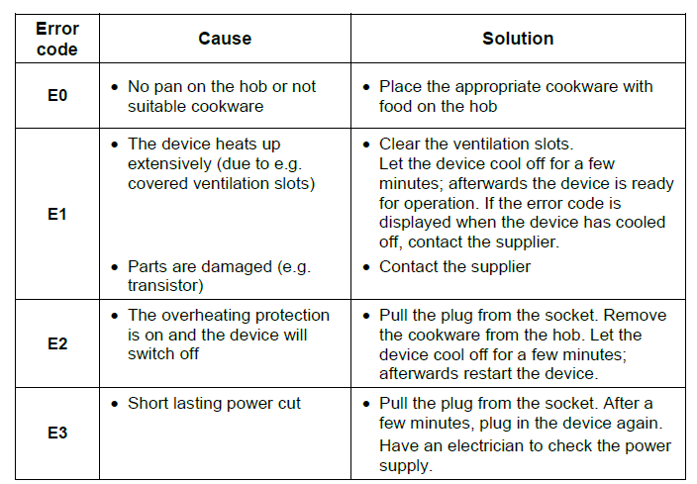
If you cannot remove the malfunctions:
- do not open the body,
- notify the customer service point or contact the sales agent, while providing the following information:
▪ type of malfunction;
▪ article and serial number (rating plate at the rear of the device);
date of purchase.

