ELECTRIC FRYER

USER’S MANUAL

Electric Fryer is designed by advantages of overseas products.
They are special designed for Fast-food restaurant. They have features of new style, well structure, easy operation and fast heated.

Features
  - 6KW powerful heater with 10Litres oil capacity each;
  - Split tank with separate control system;
  - Robust structure with drain tap;
  - 230 ℃ hi-limit ensures safety operation;
  - Stainless steel tank with oil level;
  - Stainless steel night cover with Bakelite handle, cool to touch;
  - Wire mesh net to collect fried crumbs from food and protect heater;
  - Heater lifting mechanism to make cleaning easy and comfortable;
  - Power and heating indictors;
  - Heavy duty steel foot;
  - Bottom cold zone to prevent food debris scorching;
  - Thermostat 50-190℃;
  - Nickel coating basket.

Technical parameter
Model | DF-10L-2
Name | ELECTRIC FRYER
Voltage | 220-240V, 50/60Hz
Power | 6+6KW
Oil Capacity | 10L*2
Size | 400x800x1100mm

Transportation and storage
During transportation, the machine should be careful handled and prevent from shaking. The packaged machine should not be stored in open air long. It should be put in a ventilated warehouse without causticity gas. And it should not be put up side down. If it needs to be stored in open air temperately, measurement against raining in needed.

Safety Guarding
  - This product should be put on a smooth place. Its two sides are recommended be put more than 10cm from any obstacles and its back is over 20cm.
  - The voltage should be coordinated with the voltage in data plate. When the machine is running the voltage should not exceed±10.
  - Do not put anything in front of the switch. Install fuse and leak electricity protector.
  - Use wire at least 2.5mm² and make sure the well ground connection for safety sake.
  - Before using this product, please check al parts and power supply and ground connection.
  - The connection and installation of this product should be done by professionals.
  - Power cord draws with yellow and green two ground wires. User should use copper bolt to link up this ground wire and another safe one.
  - If user changes power cord user should use YCW oil-resisting wire with yellow and green two ground wires. Count to use by 8-10A/mm²

Operation
  - Inside the oil bowl there are two lines. The amount of oil can not lower than the low line and over the high one.
  - 1) Red light is on when power switch turns on. Turn the Temperature controller clockwise to the degree user needs. At the same time, yellow light is on and red light is off.
2) When the temperature is on the degree user needs, automatic temperature controller will cut off electricity. Yellow light is off and red light is on at the same time.
3) When temperature lowers, the automatic temperature controller will get through electricity. At the same time yellow light is on and red light is off.
  - Do not put water on the cover in order to prevent from an accident.
  - Enclosed special basket in order to fry small piece of food. After frying please hang the basket. Put directly big piece of food into oil bowl to fry.
  - After using it please turn the temperature controller counter-clockwise to the certain place and unplug the fryer.
  - Please clean dregs in a regular time.
  - Please use good vegetable oil.

Cleaning and Maintenance
  - Cut off all power when cleaning and maintaining the equipment in case of accident.
  - Do not use towel with corrosive cleanser to clean the surface of oven. Water washing is forbidden in case of shot circuit and other electric accidents.

Circuit Diagram
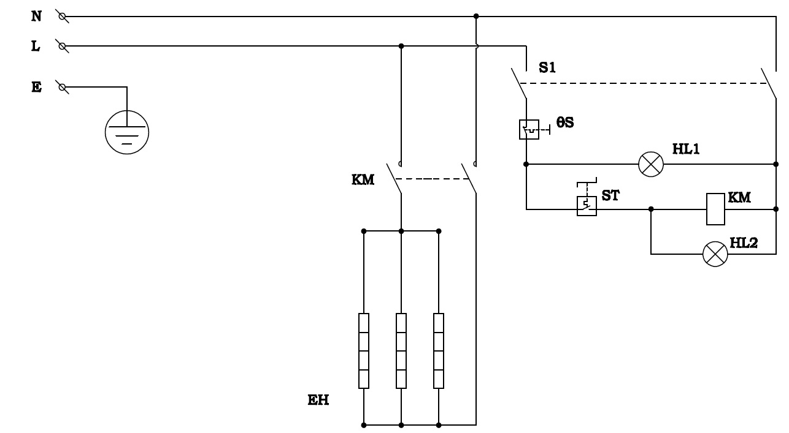

XL—TREMINAL S1—TIMER SWITCH HL1—POWER INDICATOR
HL2—WARM INDICATOR θS—TEMPEATURE LIMITER
ST—THERMOSTAT KM—AC CONTACTOR
EH1—EH2—ELECTRIC HEATING TUBE

